GERMANTOWN FRIENDS SCHOOL  NEWSLETTER  Volume # 1 |  | Welcome! My name is John Bateman and I’ll be teaching Eleventh Grade English for Germantown Friends this year! I’m very excited to get started and introduce students to a fantastic line-up of classic and modern authors. It promises to be an exciting and funfilled semester ahead and I look forward to meeting each one of you! If you have any questions starting out or are just looking to introduce yourself, please contact me at tuj18107@temple.edu.  English Literature!
“A reader lives a thousand lives before he dies, said Jojen. The man who never reads lives only one.”  - George R.R. Martin | 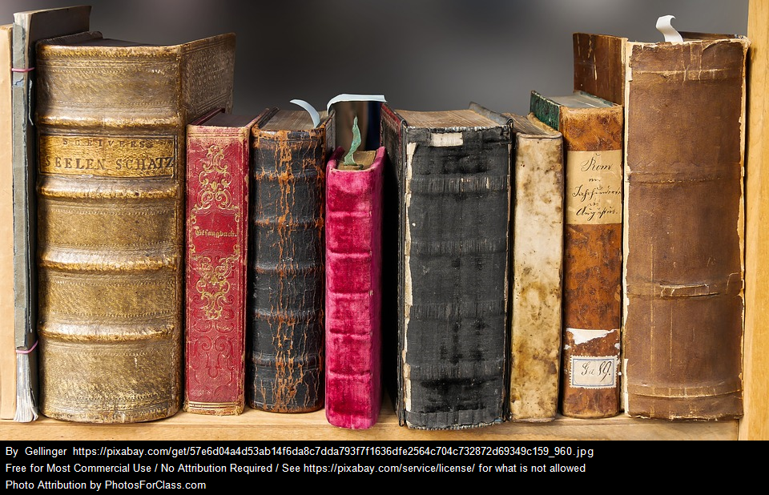
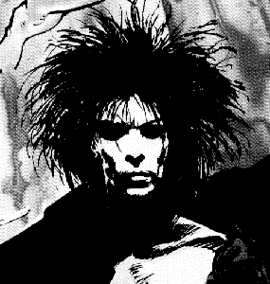 | Graphic novels  Love comic books? Batman? Spiderman? we’ll be reading both of those and many others! Get ready for our graphic novel track later in the semester to learn how some authors are taking to a new medium to showcase their work.


" Teaching is like having a secret you can’t to share. For me, that means books.”

- John Bateman (Educator)
Are Thou a Villain?  Explore the darkside of literature with our villains track. Examine Iago, Satan, Baron Harkonnan, and many others in this in-depth look into the nature of what makes someone “evil”. | 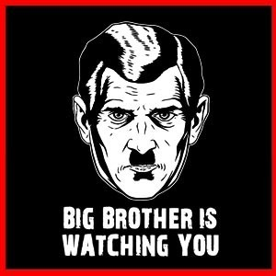

Education is the most powerful weapon which you can use to change the world.
- Nelson Mandela
CREATIVE | 

WRITING COURSES
Take the first steps into a world of your own creation! We’ll be placing a particular focus this year on creative writing in conjunction with our book tracks to learn what great writing looks like. It takes good readers to be good writers. With each section of our course, students will be writing thematically along with our authors to produce their own work and explore their literary voice. Much of this will take place with short stories, poetry, and journaling over the course of the year. Towards the end of each semester, we will pick our best works to submit to various contests and publishing companies for feedback. For parents and students who want to prepare or learn more about some of the opportunities available visit the following websites for more information:  - Scholastic Art and Writing Awards: https://www.artandwriting.org/what-we-do/the-awards/categories  - Ocean Awareness Contest: https://bowseat.org/programs/ocean-awareness-contest/  - John F. Kennedy Profile in Courage Contest: https://www.jfklibrary.org/learn/education/profile-in-courage-essay-contest/eligibility-and-requirements  - YoungArts Competition: http://youngarts.org/competition | 
 | 

